What is Prometheus?
- Prometheus is an open source monitoring tool
- Provides out-of-the-box monitoring capabilities for the Kubernetes container orchestration platform. It can monitor servers and databases as well.
- Collects and stores metrics as time-series data, recording information with a timestamp
- It is based on pull and collects metrics from targets by scraping metrics HTTP endpoints.

What is Grafana?
- Grafana is an open-source visualization and analytics software.
- It allows you to query, visualize, alert on, and explore your metrics no matter where they are stored.
- Prometheus Architecture
- 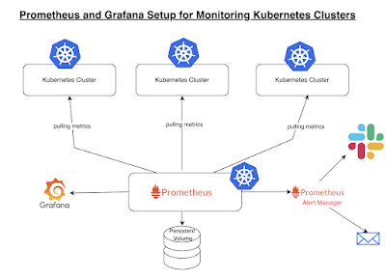

Key components:
1. Prometheus server - Processes and stores metrics data
2. Alert Manager - Sends alerts to any systems/channels
3. Grafana - Visualize scraped data in UI

Installation Method:
The are are many ways you can setup Prometheus and Grafana. You can install in following ways:
1. Create all configuration files of both Prometheus and Grafana and execute them in right order.
2. Prometheus Operator - to simplify and automate the configuration and management of the Prometheus monitoring stack running on a Kubernetes cluster
3. Helm chart (Recommended) - Using helm to install Prometheus Operator including Grafana

Why to use Helm?
Helm is a package manager for Kubernetes. Helm simplifies the installation of all components in one command. Install using Helm is recommended as you will not be missing any configuration steps and very efficient.

Pre-requisites:

EKS Cluster is setup already

Install Helm3

EC2 instance to access EKS cluster

steps to install helm:
For Linux:

curl -LO https://get.helm.sh/helm-v3.19.0-linux-amd64.tar.gz
tar -zxvf helm-v3.19.0-linux-amd64.tar.gz
sudo mv linux-amd64/helm /usr/local/bin/helm
helm version

Implementation steps
We need to add the Helm Stable Charts for your local client. Execute the below command:
Step1:
# Add prometheus Helm repo
Add the following helm repositories by the commands below.
helm repo add prometheus-community https://prometheus-community.github.io/helm-charts

# Add Helm Stable Charts for your local client
helm repo update
helm repo add stable https://charts.helm.sh/stable

Step 2: Update Helm repositories
After we add the helm repositories, we have to update the helm repo by the following command.
helm repo update

helm search repo prometheus-community

Prometheus and grafana helm chart moved to kubeprometheus stack
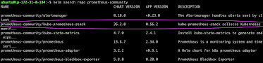
Create Prometheus namespace
kubectl create namespace prometheus

Install kube-prometheus-stack
Below is helm command to install kube-prometheus-stack. The helm repo kube-stack-prometheus (formerly prometheus-operator) comes with a grafana deployment embedded.
helm install stable prometheus-community/kube-prometheus-stack -n prometheus
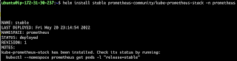
Lets check if prometheus and grafana pods are running already
kubectl get pods -n prometheus
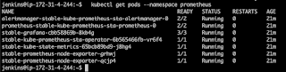

kubectl get svc -n prometheus
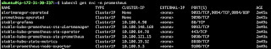

This confirms that prometheus and grafana have been installed successfully using Helm.

In order to make prometheus and grafana available outside the cluster, use LoadBalancer or NodePort instead of ClusterIP.

Edit Prometheus Service
kubectl edit svc stable-kube-prometheus-sta-prometheus -n prometheus
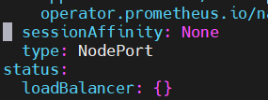

Edit Grafana Service
kubectl edit svc stable-grafana -n prometheus


Verify if service is changed to Nodeport and also to get the Nodeport which is assigned.0.

kubectl get svc -n prometheus
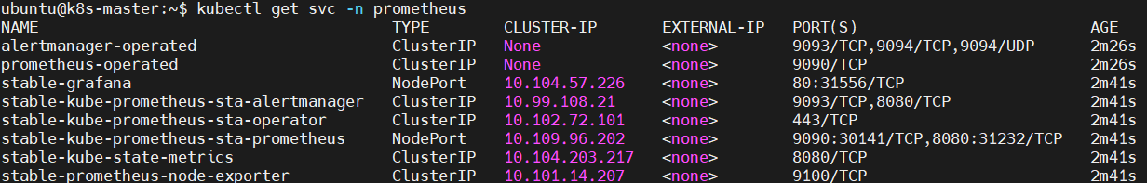

Access Grafana UI in the browser

Get the URL from the above screenshot and put in the browser

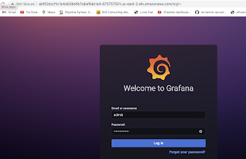

UserName: admin
Password: prom-operator

If you getting cerds issue run below commands
kubectl exec -n prometheus deploy/stable-grafana -- printenv | grep GF_SECURITY_ADMIN
GF_SECURITY_ADMIN_PASSWORD=xyofoYsSLdtTvKNsR3XOMHgIR7wdccr6jOwbMQxR
GF_SECURITY_ADMIN_USER=admin

To update cerds use below command
helm upgrade stable prometheus-community/kube-prometheus-stack \
-n prometheus \
--reuse-values \
--set grafana.adminPassword="admin123"

Once you re-deploy need to update svc file

Edit Prometheus Service
kubectl edit svc stable-kube-prometheus-sta-prometheus -n prometheus


Edit Grafana Service
kubectl edit svc stable-grafana -n prometheus


Verify if service is changed to Nodeport and also to get the Nodeport which is assigned.

Create Dashboard in Grafana

In Grafana, we can create various kinds of dashboards as per our needs.

How to Create Kubernetes Monitoring Dashboard?
For creating a dashboard to monitor the cluster:

Click '+' button on left panel and select ‘Import’.
Enter 12740 dashboard id under Grafana.com Dashboard.
Click ‘Load’.
Select ‘Prometheus’ as the endpoint under prometheus data sources drop down.
Click ‘Import’.

This will show monitoring dashboard for all cluster nodes

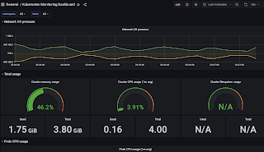

How to Create Kubernetes Cluster Monitoring Dashboard?
For creating a dashboard to monitor the cluster:

Click '+' button on left panel and select ‘Import’.
Enter 3119 dashboard id under Grafana.com Dashboard.
Click ‘Load’.
Select ‘Prometheus’ as the endpoint under prometheus data sources drop down.
Click ‘Import’.
This will show monitoring dashboard for all cluster nodes

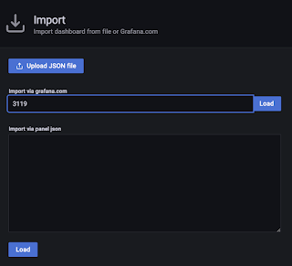

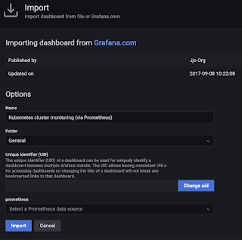

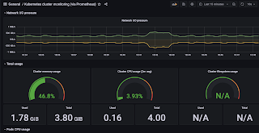

Create POD Monitoring Dashboard
For creating a dashboard to monitor the cluster:

Click '+' button on left panel and select ‘Import’.
Enter 6417 dashboard id under Grafana.com Dashboard.
Click ‘Load’.
Select ‘Prometheus’ as the endpoint under prometheus data sources drop down.
Click ‘Import’.
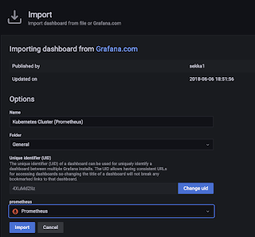

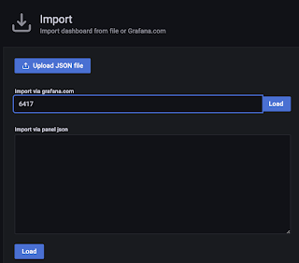

This will show monitoring dashboard for all cluster nodes.

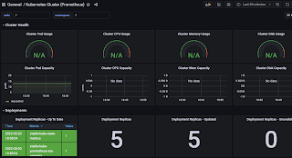
Dashboard Id --18283

